PROBLEM STATEMENT

* Total Seats:
* What are the total number of seats available for elections in each state
* Total seats won by NDA Alliance
* Seats won by NDA Alliance Parties
* Total seats won by I.N.D.I.A Alliance Parties
* Seats won by I.N.D.I.A Alliance parties
* Add new column field in table partywise_results to get the Party Allianz as NDA, I.N.D.I.A and OTHER
* Which party alliance(NDA, I.N.D.I.A, or OTHER) won the most seats across all states?
* Winning candidate’s name, their party name, total votes, and the margin of victory for a specific state and constituency?
* What is the distribution of EVM votes vs postal votes for candidates in a specific constituency?
* Which parties won the most seats in s state, and how many seats did each party win?
* What is the total number of seats won by each party alliance(NDA, I.N.D.I.A, and OTHER) in each state for the India Elections 2024
* Which candidate won and which candidate was the runner-up in each constituency of State for the 2024 elections?
* For the state of Maharashtra, what are the total number of seats, total number of candidates, total number of parties, total votes(including EVM and postal), and the breakdown of EVM and postal votes?

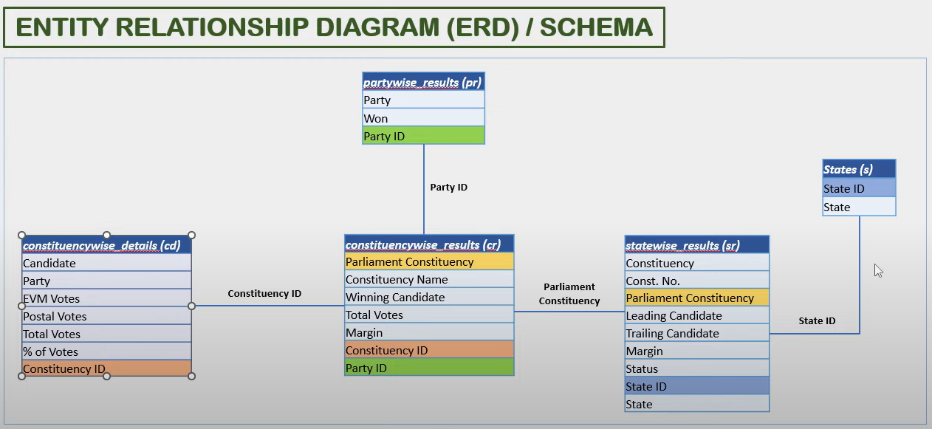

**SQL QUERIES**

**To View all the datasets**

SELECT * FROM constituencywise_details

SELECT * FROM constituencywise_results

SELECT * FROM partywise_results

SELECT * FROM statewise_results

SELECT * FROM states

1. **Total Seats:**

SELECT DISTINCT COUNT(Parliament_Constituency) AS Total_Seats

FROM constituencywise_results

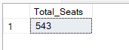

1. **What are the total number of seats available for elections in each state**

SELECT

s.state AS State_Name,

COUNT(cr.parliament_constituency) AS Total_Seats

FROM constituencywise_results cr

INNER JOIN statewise_results sr ON cr.Parliament_Constituency = sr.Parliament_Constituency

INNER JOIN states s ON sr.State_ID = s.State_ID

GROUP BY s.state

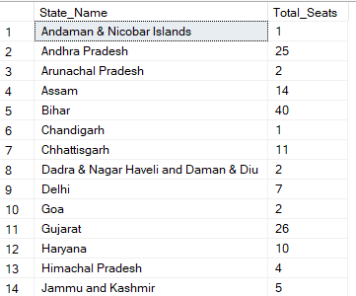

1. **Total seats won by NDA Alliance**

SELECT

SUM(CASE

WHEN party IN (

'Bharatiya Janata Party - BJP',

'Telugu Desam - TDP',

'Janata Dal (United) - JD(U)',

'Shiv Sena - SHS',

'Lok Janshakti Party(Ram Vilas) - LJPRV',

'Nationalist Congress Party - NCP',

'Janata Dal (Secular) - JD(S)',

'AJSU Party - AJSUP',

'Apna Dal (Soneylal) - ADAL',

'Hindustani Awam Morcha (Secular) - HAMS',

'Janasena Party - JnP',

'Rashtriya Lok Dal - RLD',

'Sikkim Krantikari Morcha - SKM',

'Asom Gana Parishad - AGP'

) THEN [Won]

ELSE 0

END) AS NDA_Total_Seats_Won

FROM partywise_results

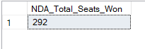

1. **Seats won by NDA Alliance Parties**

SELECT

party AS Party_Name,

won AS Seats_Won

FROM partywise_results

WHERE party IN (

'Bharatiya Janata Party - BJP',

'Telugu Desam - TDP',

'Janata Dal (United) - JD(U)',

'Shiv Sena - SHS',

'Lok Janshakti Party(Ram Vilas) - LJPRV',

'Nationalist Congress Party - NCP',

'Janata Dal (Secular) - JD(S)',

'AJSU Party - AJSUP',

'Apna Dal (Soneylal) - ADAL',

'Hindustani Awam Morcha (Secular) - HAMS',

'Janasena Party - JnP',

'Rashtriya Lok Dal - RLD',

'Sikkim Krantikari Morcha - SKM',

'Asom Gana Parishad - AGP'

)

ORDER BY Seats_Won DESC

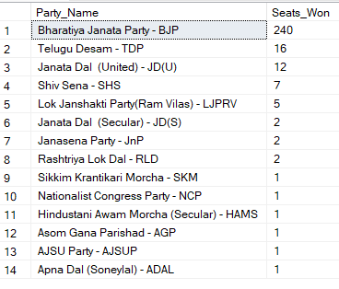

1. **Total seats won by I.N.D.I.A Alliance Parties**

SELECT

SUM(CASE

WHEN party IN(

'Indian National Congress - INC',

'Communist Party of India (Marxist) - CPI(M)',

'Aam Aadmi Party - AAAP',

'Samajwadi Party - SP',

'All India Trinamool Congress - AITC',

'Dravida Munnetra Kazhagam - DMK',

'Shiv Sena (Uddhav Balasaheb Thackrey) - SHSUBT',

'Kerala Congress - KEC',

'Communist Party of India (Marxist-Leninist) (Liberation) - CPI(ML)(L)',

'Communist Party of India - CPI',

'Indian Union Muslim League - IUML',

'Jammu & Kashmir National Conference - JKN',

'Jharkhand Mukti Morcha - JMM',

'Marumalarchi Dravida Munnetra Kazhagam - MDMK',

'Nationalist Congress Party Sharadchandra Pawar - NCPSP',

'Rashtriya Janata Dal - RJD',

'Revolutionary Socialist Party - RSP',

'Viduthalai Chiruthaigal Katchi - VCK',

'Rashtriya Loktantrik Party - RLTP',

'Bharat Adivasi Party - BHRTADVSIP'

) THEN [Won]

ELSE 0

END) AS INDIA_Total_Seats_Won

FROM partywise_results



1. **Seats won by I.N.D.I.A Alliance parties**

SELECT

party AS Party_Name,

won AS Seats_Won

FROM partywise_results

WHERE party IN(

'Indian National Congress - INC',

'Communist Party of India (Marxist) - CPI(M)',

'Aam Aadmi Party - AAAP',

'Samajwadi Party - SP',

'All India Trinamool Congress - AITC',

'Dravida Munnetra Kazhagam - DMK',

'Shiv Sena (Uddhav Balasaheb Thackrey) - SHSUBT',

'Kerala Congress - KEC',

'Communist Party of India (Marxist-Leninist) (Liberation) - CPI(ML)(L)',

'Communist Party of India - CPI',

'Indian Union Muslim League - IUML',

'Jammu & Kashmir National Conference - JKN',

'Jharkhand Mukti Morcha - JMM',

'Marumalarchi Dravida Munnetra Kazhagam - MDMK',

'Nationalist Congress Party Sharadchandra Pawar - NCPSP',

'Rashtriya Janata Dal - RJD',

'Revolutionary Socialist Party - RSP',

'Viduthalai Chiruthaigal Katchi - VCK',

'Rashtriya Loktantrik Party - RLTP',

'Bharat Adivasi Party - BHRTADVSIP'

)

ORDER BY Seats_Won DESC

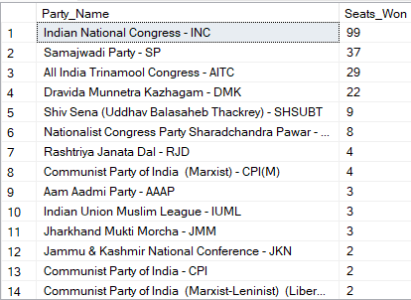

1. **Add new column field in table partywise_results to get the Party Allianz as NDA, I.N.D.I.A and OTHER**

ALTER TABLE partywise_results

ADD party_alliance VARCHAR(50)

UPDATE partywise_results

SET party_alliance = 'I.N.D.I.A'

WHERE party IN(

'Indian National Congress - INC',

'Communist Party of India (Marxist) - CPI(M)',

'Aam Aadmi Party - AAAP',

'Samajwadi Party - SP',

'All India Trinamool Congress - AITC',

'Dravida Munnetra Kazhagam - DMK',

'Shiv Sena (Uddhav Balasaheb Thackrey) - SHSUBT',

'Kerala Congress - KEC',

'Communist Party of India (Marxist-Leninist) (Liberation) - CPI(ML)(L)',

'Communist Party of India - CPI',

'Indian Union Muslim League - IUML',

'Jammu & Kashmir National Conference - JKN',

'Jharkhand Mukti Morcha - JMM',

'Marumalarchi Dravida Munnetra Kazhagam - MDMK',

'Nationalist Congress Party Sharadchandra Pawar - NCPSP',

'Rashtriya Janata Dal - RJD',

'Revolutionary Socialist Party - RSP',

'Viduthalai Chiruthaigal Katchi - VCK',

'Rashtriya Loktantrik Party - RLTP',

'Bharat Adivasi Party - BHRTADVSIP'

);

UPDATE partywise_results

SET party_alliance = 'NDA'

WHERE party IN(

'Bharatiya Janata Party - BJP',

'Telugu Desam - TDP',

'Janata Dal (United) - JD(U)',

'Shiv Sena - SHS',

'Lok Janshakti Party(Ram Vilas) - LJPRV',

'Nationalist Congress Party - NCP',

'Janata Dal (Secular) - JD(S)',

'AJSU Party - AJSUP',

'Apna Dal (Soneylal) - ADAL',

'Hindustani Awam Morcha (Secular) - HAMS',

'Janasena Party - JnP',

'Rashtriya Lok Dal - RLD',

'Sikkim Krantikari Morcha - SKM',

'Asom Gana Parishad - AGP'

);

UPDATE partywise_results

SET party_alliance = 'OTHER'

WHERE party_alliance IS NULL;

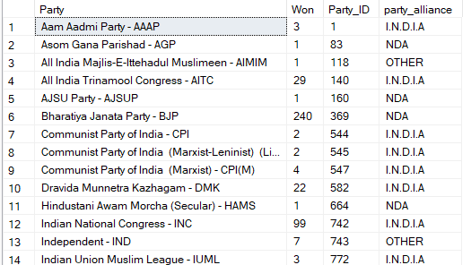

1. **Which party alliance(NDA, I.N.D.I.A, or OTHER) won the most seats across all states?**

SELECT party_alliance,

SUM(won) AS Seats_Won

FROM partywise_results

GROUP BY party_alliance

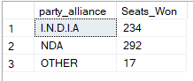

1. **Winning candidate’s name, their party name, total votes, and the margin of victory for a specific state and constituency?**

SELECT cr.Winning_Candidate,

pr.party,

pr.party_alliance,

cr.total_votes,

cr.margin,

s.state,

cr.Constituency_Name

FROM constituencywise_results cr

INNER JOIN partywise_results pr ON cr.party_id = pr.Party_ID

INNER JOIN statewise_results sr ON cr.Parliament_Constituency = sr.Parliament_Constituency

INNER JOIN states s ON sr.State_ID = s.State_ID

WHERE s.State = 'Uttar Pradesh' AND cr.Constituency_Name = 'GHAZIABAD'



1. **What is the distribution of EVM votes vs postal votes for candidates in a specific constituency?**

SELECT

cd.EVM_Votes,

cd.Postal_Votes,

Cd.Total_Votes,

cd.Candidate,

cr.Constituency_Name

FROM constituencywise_results cr JOIN constituencywise_details cd

ON cr.Constituency_ID = cd.Constituency_ID

WHERE cr.Constituency_Name = 'AMETHI'

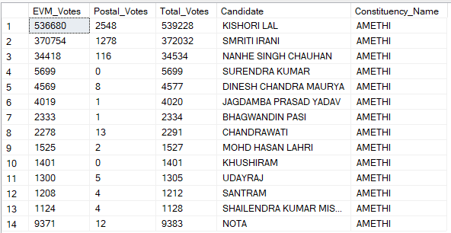

1. **Which parties won the most seats in s state, and how many seats did each party win?**

SELECT

pr.Party,

COUNT(cr.Constituency_ID) AS Seats_Won

FROM

constituencywise_results cr

JOIN

partywise_results pr ON cr.Party_ID = pr.Party_ID

JOIN

statewise_results sr ON cr.Parliament_Constituency = sr.Parliament_Constituency

JOIN states s ON sr.State_ID = s.State_ID

WHERE

s.state = 'Uttar Pradesh'

GROUP BY

pr.Party

ORDER BY

Seats_Won DESC;

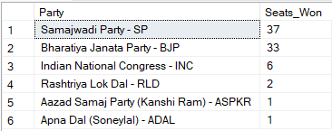

1. **What is the total number of seats won by each party alliance(NDA, I.N.D.I.A, and OTHER) in each state for the India Elections 2024**

SELECT

s.State AS State_Name,

SUM(CASE WHEN p.party_alliance = 'NDA' THEN 1 ELSE 0 END) AS NDA_Seats_Won,

SUM(CASE WHEN p.party_alliance = 'I.N.D.I.A' THEN 1 ELSE 0 END) AS INDIA_Seats_Won,

SUM(CASE WHEN p.party_alliance = 'OTHER' THEN 1 ELSE 0 END) AS OTHER_Seats_Won

FROM

constituencywise_results cr

JOIN

partywise_results p ON cr.Party_ID = p.Party_ID

JOIN

statewise_results sr ON cr.Parliament_Constituency = sr.Parliament_Constituency

JOIN

states s ON sr.State_ID = s.State_ID

WHERE

p.party_alliance IN ('NDA', 'I.N.D.I.A', 'OTHER') -- Filter for NDA and INDIA alliances

GROUP BY

s.State

ORDER BY

s.State;

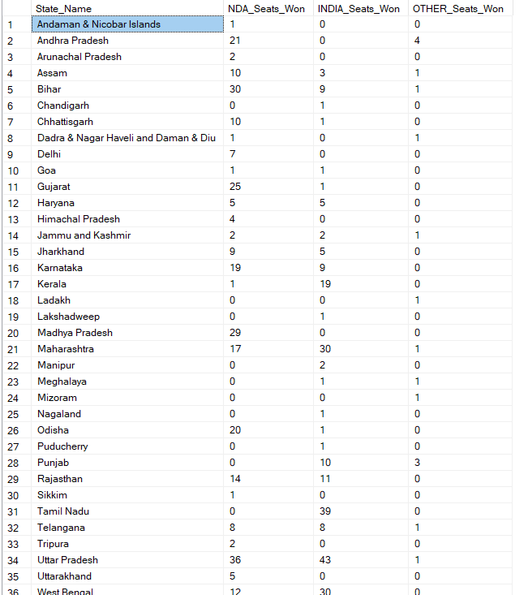

1. **Which candidate won and which candidate was the runner-up in each constituency of State for the 2024 elections?**

WITH RankedCandidates AS (

    SELECT

        cd.Constituency_ID,

        cd.Candidate,

        cd.Party,

        cd.EVM_Votes,

        cd.Postal_Votes,

        cd.EVM_Votes + cd.Postal_Votes AS Total_Votes,

        ROW_NUMBER() OVER (PARTITION BY cd.Constituency_ID ORDER BY cd.EVM_Votes + cd.Postal_Votes DESC) AS VoteRank

    FROM

        constituencywise_details cd

    JOIN

        constituencywise_results cr ON cd.Constituency_ID = cr.Constituency_ID

    JOIN

        statewise_results sr ON cr.Parliament_Constituency = sr.Parliament_Constituency

    JOIN

        states s ON sr.State_ID = s.State_ID

    WHERE

        s.State = 'Maharashtra'

)

SELECT

    cr.Constituency_Name,

    MAX(CASE WHEN rc.VoteRank = 1 THEN rc.Candidate END) AS Winning_Candidate,

    MAX(CASE WHEN rc.VoteRank = 2 THEN rc.Candidate END) AS Runnerup_Candidate

FROM

    RankedCandidates rc

JOIN

    constituencywise_results cr ON rc.Constituency_ID = cr.Constituency_ID

GROUP BY

    cr.Constituency_Name

ORDER BY

    cr.Constituency_Name;

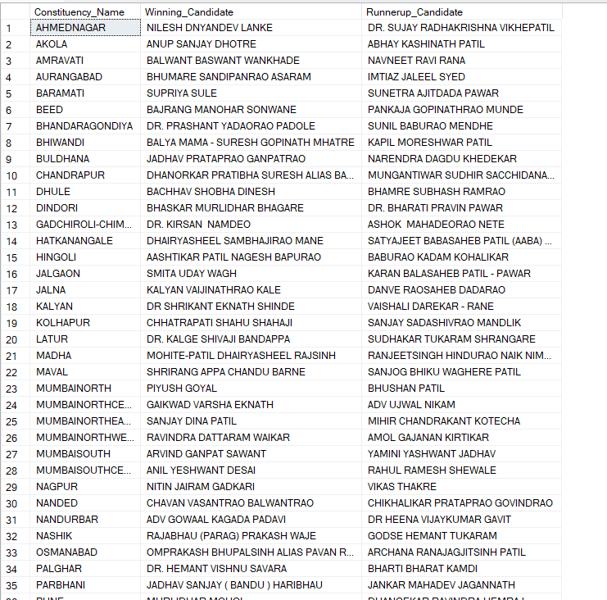

1. **For the state of Maharashtra, what are the total number of seats, total number of candidates, total number of parties, total votes(including EVM and postal), and the breakdown of EVM and postal votes?**

SELECT

COUNT(DISTINCT cr.Constituency_ID) AS Total_Seats,

COUNT(DISTINCT cd.Candidate) AS Total_Candidates,

COUNT(DISTINCT pr.Party) AS Total_Parties,

SUM(cd.EVM_Votes + cd.Postal_Votes) AS Total_Votes,

SUM(cd.EVM_Votes) AS Total_EVM_Votes,

SUM(cd.Postal_Votes) AS Total_Postal_Votes

FROM constituencywise_results cr

JOIN

constituencywise_details cd ON cr.constituency_ID = cd.Constituency_ID

JOIN

statewise_results sr ON sr.Parliament_Constituency = cr.Parliament_Constituency

JOIN

partywise_results pr ON cr.Party_ID = pr.Party_ID

JOIN

States s ON s.State_ID = sr.State_ID

WHERE

s.State = 'Maharashtra';

